**Employee Attrition Analysis Report**

Haroon Mirza

MIS-490  
Professor Gray

**Intro**

Looking for more information to understand the business more broadly, this report looks into the attrition rates among ABC company and its employees. Understanding how we can keep talent on board is essential for our expansion, as we will need more employees to expand. The goal of this report is to help utilize this information to make strategic decisions.

**Job Satisfaction**

One of the most interesting findings is that majority of employees who leave the company in their first year had an average job satisfaction rating of 2.72 out of 4. This is a hint that job satisfaction is an important factor when it comes to keeping employees and is something that should be improved upon.

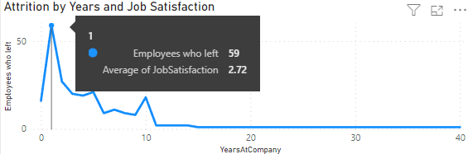

**Income**

A major finding that I have found most apparent is that when it came to pay, those who earned less often left. More specifically, they had been paid between $2,000 to $3,000 less on average than those who stayed. The difference in Income should be suggested to be a major influence in contributing to attrition.

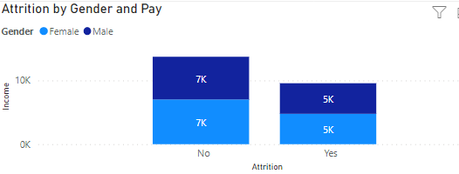

**The Role of Education in Attrition**

Apparently, attrition rate was relatively close for all education levels, with a tiny decrease on the highest educated. Those who had up to the first three education levels had an attrition rate of about 18% -15%, but for the last two levels it was around 10-14%.

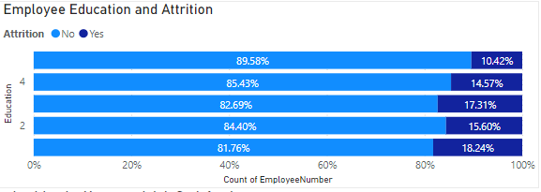

**Job Roles**

Depending on the job roles, they had quite higher attrition rates compared to other positions. The top three were laboratory technicians, sales executives, and research scientists. These should be the positions we focus the most on reducing attrition.

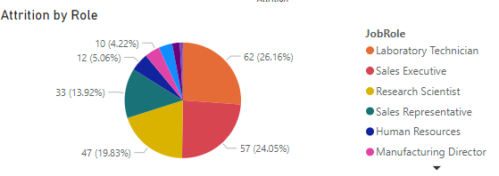

**Departmental Analysis**

Sales is the most volatile department, having the highest average pay but also the highest attrition rates, as they should be a key department to target when it comes to reducing attrition. Improving sales performance would likely be key when it comes to reducing attrition here. This is also a sign that pay isn’t necessarily the key to reducing attrition, as it did not stop this department from having the highest rate.

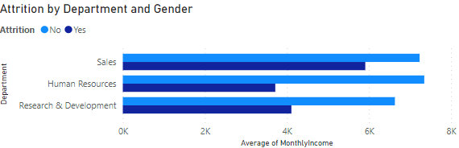

**Age and Its Relation to Attrition**

The ages that had the highest attrition rates were 29, 34, and 35 years old, but are also the most common ages within the company. The attrition rate when it comes to age is pretty small and so may not be the most useful. But it is good to clarify.

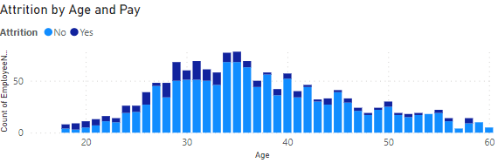**Recommendations and Conclusion**

In conclusion, the key suggestions for the company would be to increase salary, targeting programs and specific focuses on certain age groups and job roles, and creating training/development plans, especially for employees with lower education levels would be useful.